The choice of Decision Tree Regression over Linear Regression depends on the nature of the data and the relationship between features and the target variable. Here's why Decision Tree Regression might have been used in this case and whether Linear Regression could be an alternative:

Why Use Decision Tree Regression?
- Non-linear Relationships:
  - Decision Tree Regression is better suited for data where the relationship between features (Size_sqft and Bedrooms) and the target (Price_in_thousands) is non-linear.
  - If house prices increase in a way that doesn’t follow a straight line (e.g., sudden jumps in price based on size or number of bedrooms), a decision tree can capture these patterns effectively.
  - For example, in real estate, a small change in house size might lead to significant price differences beyond a certain threshold.
- Automatic Feature Interaction:
  - Decision Trees automatically capture interactions between features, such as the combined effect of Size_sqft and Bedrooms on the price.

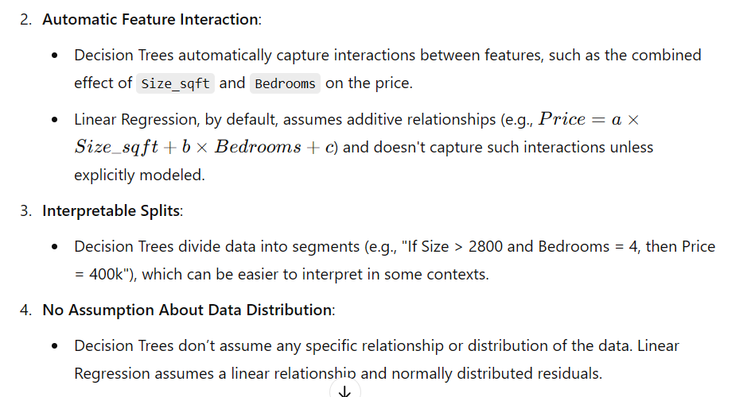

Could We Use Linear Regression?
Yes, Linear Regression could be used, but it depends on whether its assumptions hold:
- Linearity:
  - If the relationship between the features and the target is approximately linear, Linear Regression would work well.
  - In this dataset, if you plot Price_in_thousands against Size_sqft and Bedrooms, and the points roughly form straight lines, Linear Regression could be appropriate.
- Continuous Data:
  - Linear Regression works best with continuous, numerical data. In this case, Size_sqft and Price_in_thousands are continuous, but Bedrooms is more categorical in nature (integer values representing counts). Decision Trees handle categorical-like features better.
- Extrapolation:
  - Linear Regression is better at extrapolation (predicting values outside the range of training data), whereas Decision Trees make predictions based on seen splits.
  - If Size_sqft = 2800 and Bedrooms = 4 fall outside the patterns captured by the decision tree, the prediction might not generalize well.

Practical Considerations
- If the relationship between size, bedrooms, and price is roughly linear, Linear Regression could work and might be simpler and faster.
- However, if the data has non-linear patterns (e.g., certain combinations of size and bedrooms drastically increase price), Decision Tree Regression would likely perform better.

Summary
- Decision Tree Regression was likely chosen because it doesn’t assume linearity and can handle non-linear patterns and feature interactions better.
- Linear Regression could be used if the relationship between features and price is roughly linear.
- The choice depends on the underlying data pattern. For a non-linear relationship, Decision Tree Regression is more appropriate.

